HONG KONG INSTITUTE OF VOCATIONAL EDUCATION
Laboratory 7b: Tkinter

TASK:
1. You’re going to design the UI of following program. The UI design are given below.

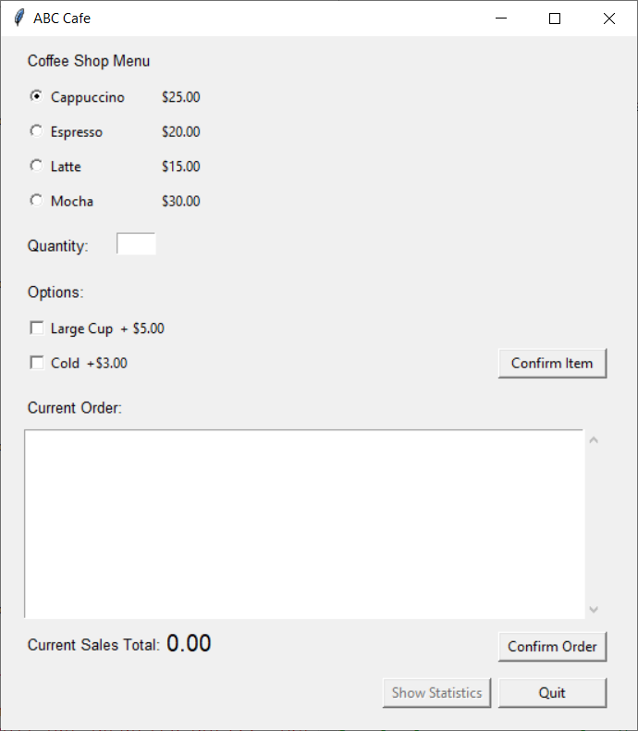
lbl_menu, font=(“bold”,10), x=20, y=10
rdo_coffee_cappuccino, variable= var_coffee, x=20, y=40
rdo_coffee_espresso, variable= var_coffee, y=70
rdo_coffee_latte, variable= var_coffee, y=100
rdo_coffee_mocha, variable= var_coffee, y=130
lbl_quantity
ent_quantity, x=100, y=170
lbl_options, y=210
chk_options_large, var=var_options_large, y=240
chk_options_cold, var=var_options_cold, y=270
btn_confirm_item, width=12, command=confirm_item, x=430
lbl_current_order, x=20, y=310
txt_currnt_order, width=60, hight=10, x=20, y=340
lbl_current_sales_total, x=20, y=515
lbl_current_sales_total_large, x=140, y=510, font=("bold",15)
btn_statistics, state=tkinter.DISABLED, x=330, y=555
btn_quit
btn_confirm_order

When user selects corresponding coffee, quantity, options and click confirm item, items will be added to the current order item list. Multiple items with different options may be added for an order. User can click “Confirm Order” after reviewing the ordered items and sales total to submit this order. Statistics page can be show up by clicking the “Show Statistics” button.
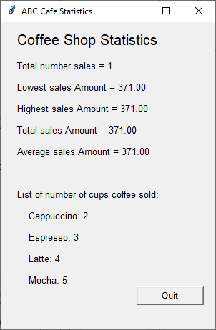
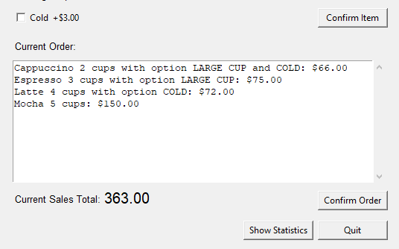

Warning message and Information message would be shown if user have invalid input in the quantity entry box, or user submitted an empty order
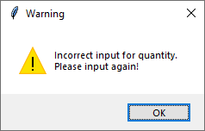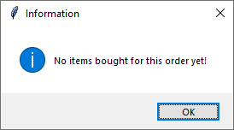

Source code of class Order:

class Order:
LARGE_CUPE_PRICE = 5
COLD_PRICE = 3
COFFEE_LIST = [("Cappuccino",25),("Espresso",20),
("Latte",15),("Mocha",30)]
__current_sales_list = list()
#static variables used for statistics
__total_number_sales = 0
__lowest_sales_amount = sys.maxsize
__highest_sales_amount = 0
__total_sales_amount = 0
__cups_of_coffee_sold = {"Cappuccino":0, "Espresso":0,
"Latte":0, "Mocha":0}
def __init__(self,name, quantity, large_cup, cold):
self.__coffee_name = name
self.__coffee_quantity = quantity
self.__large_cup = large_cup
self.__cold = cold

def get_coffee_name(self):
return self.__coffee_name

def get_quantity(self):
return self.__coffee_quantity

def calculate_current_sales(self):
sales = Order.get_coffee_price(self.__coffee_name)
if self.__large_cup:
sales += Order.LARGE_CUPE_PRICE
if self.__cold:
sales += Order.COLD_PRICE
return sales * self.__coffee_quantity

@staticmethod
def get_total_number_sales():
return Order.__total_number_sales
@staticmethod
def get_lowest_sales_amount():
return Order.__lowest_sales_amount
@staticmethod
def get_highest_sales_amount():
return Order.__highest_sales_amount
@staticmethod
def get_total_sales_amount():
return Order.__total_sales_amount
@staticmethod
def get_cups_of_coffee_sold(coffee_name):
return Order.__cups_of_coffee_sold.get(coffee_name,0)
@staticmethod
def get_coffee_price(coffee_name):
for i in Order.COFFEE_LIST:
if i[0]==coffee_name:
return i[1]

@staticmethod
def confirm_order():
Order.__total_number_sales += 1
current_sales = Order.calculate_current_sales_total()
if (Order.calculate_current_sales_total() <
Order.__lowest_sales_amount):
Order.__lowest_sales_amount = current_sales
if (Order.calculate_current_sales_total() >
Order.__highest_sales_amount):
Order.__highest_sales_amount = current_sales
Order.__total_sales_amount += current_sales
for i in Order.__current_sales_list:
Order.__cups_of_coffee_sold[i.get_coffee_name()] = Order.__cups_of_coffee_sold.get(i.get_coffee_name(),0) + i.get_quantity()

#empty current sales list after order is confirmed
Order.__current_sales_list = list()

@staticmethod
def calculate_current_sales_total():
total = 0
for i in Order.__current_sales_list:
total += i.calculate_current_sales()
return total

@staticmethod
def get_current_sales_list():
return Order.__current_sales_list

@staticmethod
def add_into_list(order):
Order.__current_sales_list.append(order)

#Used for display sales records in current order text area
def __str__(self):
option = ""
if self.__large_cup or self.__cold:
option += " with option "
if self.__large_cup:
option += "LARGE CUP"
if self.__large_cup and self.__cold:
option += " and "
if self.__cold:
option += "COLD"
return (f"{self.__coffee_name} " +
f"{self.__coffee_quantity} " +
f"cups{option}: " +
f"${self.calculate_current_sales():.2f}\n")

Answer:

